H.T No
Regulations:
A18

Sreenidhi Institute of Science and Technology
(An Autonomous Institution)
Code No: 7HC13 Date: 03-Sept-2024 (FN)

B.Tech II-Year I- Semester External Examination, September - 2024 (Supplementary)
TRANSFORM TECHNIQUES AND NUMERICAL METHODS (EEE and ECE)

Time: 3 Hours Max.Marks:70

Note: a) No additional answer sheets will be provided.
b) All sub-parts of a question must be answered at one place only, otherwise it will not be valued.
c) Missing data can be assumed suitably.

Bloom's Cognitive Levels of Learning (BCLL)

Remember | L1 | Apply | L3 | Evaluate | L5
Understand | L2 | Analyze | L4 | Create | L6

Part - A Max.Marks:20
Answer all QUESTIONS

 |  | BCLL | CO(s) | Marks
1 | Find 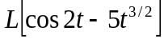 | L2 | CO1 | [2M]
2 | Evaluate 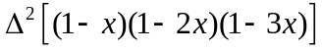 | L1 | CO2 | [2M]
3 | Classify the PDE 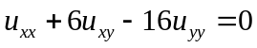 | L1 | CO3 | [2M]
4 | Evaluate Z(na^{n} ) | L2 | CO4 | [2M]
5 | Find 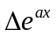with h=1 | L2 | CO5 | [2M]
6 | What is Newton’s forward interpolation formula ? | L1 | CO6 | [2M]
7 | Find 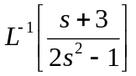 | L2 | CO1 | [2M]
8 | Write Runge-Kutta second and fourth order formulae. | L1 | CO3 | [2M]
9 | Write the formula for Runge-kutta method of fourth order. | L1 | CO5 | [2M]
10 | Write one dimensional heat equation and its solution. | L2 | CO4 | [2M]
Part – B Max.Marks:50
ANSWER ANY FIVE QUESTIONS. EACH QUESTION CARRIES 10 MARKS.

 |  |  | BCLL | CO(s) | Marks
11. | a) | Using bisection method find the approximate root of the equation  x⁴-4x-10=0 . | L3 | CO1 | [5M]
 | b) | Evaluate the value of √12 using Newton-Raphson method. | L3 | CO1 | [5M]
12. |  | 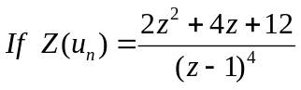 then find 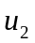 and 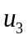 | L4 | CO2 | [10M]
13. |  | Apply Range – Kutta method of 4th order find the approximate value of y when x=0.2 in steps of 0.1, given that  = x+y², y(0) = 1. | L3 | CO3 | [10M]
14. | a) | Find the positive real root of the equation 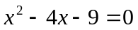by using Newton Raphson method. | L3 | CO4 | [5M]
 | b) | Using Simpson’s 1/3rd rule, find the value of the integral 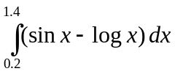by taking 6 sub-intervals. | L3 | CO4 | [5M]
15. | a) | State and prove Damping Rule in Z -Transforms. | L3 | CO5 | [5M]
 | b) | Find Inverse Z transform of 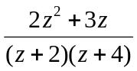 | L3 | CO5 | [5M]
16. |  | Using R-K method, estimate y(0.2) and y(0.4) for the equation 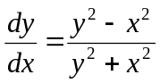 y(0)=1 with h=0.2. | L3 | CO6 | [10M]
17. | a) | Find 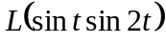 | L3 | CO1 | [4M]
 | b) | Find 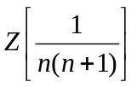 | L3 | CO2 | [3M]
 | c) | Form a PDE by the elimination of arbitrary constants from 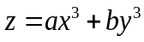 | L3 | CO3 | [3M]
18. | a) | Find the interpolating polynomial for the following data using Newton’s Backward interpolation formula. | L3 | CO5 | [5M]
  x | 1 | 2 | 3
  f(x) | 1 | 2 | 9
 | b) | Use picard’s method to approximate y when x=0.5. Given that y=1 when x=0 and 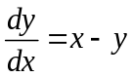 | L2 | CO6 | [5M]

-- 00 -- 00 –

